**World Hunger and Distribution of Food**

Vivienne Zhu

Vera Protopopova

Corey Strickland

Seidenberg School of Computer Science, Pace University

CS 232 Computer Organization

Every person is familiar with the feeling of hunger. Overcoming the feeling of hunger can be very simple — you should at least eat a piece of bread or any other food. However, if there is no access to food, after a certain time the person dies. Hunger has been a mankind’s struggle throughout the history, but we cannot ignore the fact that even today, despite the availability of modern production of food, many people are still malnourished and are tormented by famine. Even now, in the 21st century, the world has about 850 million people suffering from hunger. Statistics show that malnutrition and hunger kill around eleven million children under the age of five each year. This is more than the population of New York City. Hunger is the cause of one third of child deaths.

Most people die from hunger due to long-term malnutrition caused by poverty. One of the causes of poverty is unequal distribution of food reserves. While many people don’t have access to food despite the fact that in the United States alone, the amount of the food that is produced is 40% higher than the food that is consumed, resulting in enormous food wastage. Statistics estimate that in the United States the 40% of wasted food correlate to 1500 kcal per person, meaning this food could have been used to feed roughly 120,000,000 people (Hence the 2016 United States population is 322,762,018). Base on the World Hunger Education Service (WHES) organization, “For the world as a whole, per capita food availability has risen from about 2220 kcal/person/day in the early 1960s to 2790 kcal/person/day in 2006-08, while developing countries even recorded a leap from 1850 kcal/person/day to over 2640 kcal/person/day” (World Hunger and Poverty Facts, 2015). As a matter of fact, enough food is produced worldwide to feed all the people in the world. An inadequate food distribution in the societies is the main cause of world hunger despite the enormous food wastage. This paper presents the solution to world hunger in the form of a software application, which will help buyers and food producers to reduce food wastage and contribute to the equal access to food worldwide. This application will help people put use to all modern resources, science and technology to help people in need.

In Today’s world, people are able to use technology and big data to solve anything. Software and geo-mapping can be used to impact global issues. Unlike today, even few decades ago, we were not able to achieve that because we were not distributing the resources to people who were truly in need (“Stop Hunger,” 2014). Today, software allows people to show where the resources go and how many people have access to it as well as how many people need help, which is the main goal of the application.

The application will reduce the gap of food distribution by connecting the food suppliers to consumers, and creating a different market. This concept will be pursued by having a buyer and seller portal in the application. Both buyers and sellers will be able to create their own account with corresponding tools. Both the suppliers and Consumers will have an interacting map, through which they will be able to communicate with each other. Producers will be able to upload their products and set their price as well as their location. The consumers will see this information on their portal and will be able to choose the best option for them. The application will also have a “donate food” option that will reduce the food wastage.

Before finding a solution to world hunger, the major factors of this problem have to be defined and analyzed. When looking at the country’s poverty statistics, analyzing the Gross Domestic Product or the income of the country is irrelevant. Different countries have different per capita income for overall population and GDP. However, those indexes are not related to the poverty level in the country. Poverty relies on the country’s income distribution. For example, In Brazil, the Gross-National Product is significantly higher than the one in Hungary (GDP per Capita, n.d.). Yet, Brazil’s poverty level skyrocket compared to Hungary (World Population by Income, 2015). Figure 1 below explains what percentage of the total income of the nation. It accounts for every 20% of the population, ranked by income level - from a wealthy individual or family to the poor. The graph shows that 20 % of Hungary's wealthiest population receives about 4 times more than 20 % of the poorest. At the same time the income of the richest individuals in Brazil is 30 times higher than the 20% of the lower class. This problem is highly dependent on the government’s social reforms that would address the problem of unequal income distribution. From the graph below, we can see that the gap between rich people and poor people is very large. Even though there are people who have enough money to buy enough food or even redundant food, there are still people who cannot afford the price of food and suffer from hunger (World Population by Income, 2015*).*

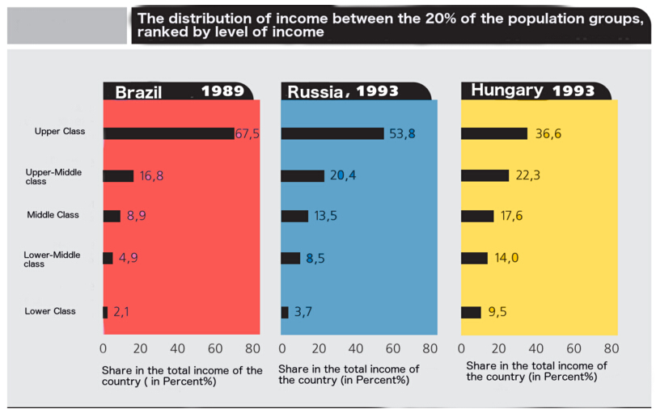

**Figure 1**. The Distribution of Income

The rising price of food is a huge factor of famine and malnutrition all over the world.  Besides low income, inflation on the price of food plays a huge role in its affordability. For example, in United States, The main cause of increase of hunger in 2007 compared with 2003-2005 is the increase of food prices. The index of food prices began to rise in 2002, after four decades of predominantly declining trends, and rose sharply in 2006 and 2007. By mid-2008, real prices for food rose by 64 percent compared with 2002 levels. Despite those price changes, people’s salaries stay the same, which causes many people and families to starve. In many areas, the inflation of food price is affected by different factors such as the transportation (which is highly dependent on the price of fuel) and the environment conditions in which the food was raised. According to a U.S. economy expert Kimberly Amadeo (2016), “Oil byproducts are used to make fertilizer. That contributes 20% of the cost of raising grain.  Higher oil prices increase corn, wheat, and soybean cost by 40% between 2001 and 2007.” As the prices of oil go up, the prices of oil byproducts that are used to grow crops also go up, and therefore the prices of crops are higher than before. Similarly, when the prices of fuel go up, the cost of food transportation will go up too. The environment also plays a tremendous role in food price. For example the El Nino climate has caused the prices of fruit and vegetables to drop, since it caused higher growth rate of those foods. At the same time, bad climate can do the opposite at a much higher rate. Experts explain that “the California drought, one of the worst on record, resulted in higher prices for fresh fruits, vegetables, and nuts. Fruit prices were forecast to raise 4.5 - 5.5%. They actually rose 3.8%” (Amadeo, 2016*).* Atrocious weathers reduce the revival rates of crops. When there is a shortage of food, supply will be less than demand, and thus the prices of food go up. As stated in Table 1, overall food costs are expected to increase 2-4% in 2016. Therefore, it will be more difficult for poor people to afford the prices of foods.

**Table 1**. Food price inflation %

|  |  |
| --- | --- |
| **Category** | **2016 price increase** |
| Meats | 2.5-4.5% |
| Fish and seafood | 1-3% |
| Dairy and eggs | 0-2% |
| Grains | 0.2% |
| Fruits and nuts | 2.5-4.5% |
| Vegetables | 2-4% |
| Overall food costs | 2-4% |

In order to solve the problem of which consumers are not able to afford the price of food, the software application will bring up a list of foods and then have a search option. Consumers can see the price of the product they chose on the map. Also if the product is not affordable to them, the application search will have “alternatives” bar that will bring up a list of products that have similar nutrition as the food they want but with cheaper prices.

Agriculture, as well as other forms of material production, in most developing countries do not correspond to the scientific and technical level of the world economy. In developed countries, the production does not carry out the needs of the population because it doesn’t have a sufficient number of machines, fertilizers, use of irrigation, etc. (Inadequate Food Distribution Systems, 2014). The difficulty lies in the fact that the population is growing faster than the food supply. The problem of hunger is closely linked with the problem of the "third world" underdevelopment, when compared to developed countries. To solve this problem, people need to increase crop yields and livestock productivity. Providing people with agricultural technology will help them defeat hunger without exterior help (Inadequate Food Distribution Systems, 2014).

Metropolises and transnational corporations are to blame in regards to the issue of hunger in developing countries. It is known that the big corporations, that produce the product for export, use the best territory, and harm the local communities. When certain products are produced in large quantities, it can harm the area where they are grown. Sometimes growing the same crops can harm the soil, but farmers still do it, because this is the only way to survive for them. In other cases, it can deplete food stocks available to the people of that region, if crop formerly used for local needs.

To reduce the risk of the factor described above, the application will notify its users about better alternate ways to buy local products for basic consumption. The software will carry this concept in an educational form. It will support agricultural education of the local farmers, and have information about raising crops, as well as competing with the exporting firms. This educational option will be in the marketing section of the application.

Every day, millions of people are dying of famine while tons of food is wasted. This earth has enough food to feed every person, but because of food waste, many people don’t have access to it. Many households and businesses waste food on daily bases. “According to a [2005 study](http://www.ce.cmu.edu/~gdrg/readings/2006/12/19/Jones_UsingContemporaryArchaeologyAndAppliedAnthropologyToUnderstandFoodLossInAmericanFoodSystem.pdf) at the University of Arizona, food waste as a percentage of the total food used is 9.55% in fast food establishments and 3.11% in full service restaurants in the United States” (“Restaurants,” n.d.). Besides restaurants, in many rich families, people buy overmuch food. Often they cannot finish eating all the food they have bought before the foods are decayed.

In our application, users can enter what food they have bought in what date, and the application will show when the food is about to become unsafe to eat. It also gives information how people can combine the food that they have bought in a meal. There will be a donate option in the application. If there is any restaurant or anyone that have too much food, they can also choose to donate some food to the people who are poor and suffer from hunger.

Transportation is also a big concern. Consumers have difficulties to purchase food because of their inability to access food markets. Because of the lack of transportation and roads, the areas become isolated and therefore, farmers cannot sell their crops. According to the article, “Inadequate Food Distribution Systems,” (2014), “About 16% of the rural populations in developing countries lack convenient access to a market, which typically causes farmers not to sell their crops. In fact, it is estimated that at most 40% of the any crop is marketed and only one-third of farmers sell to markets.” This leads to poverty, since those areas are not highly profitable, so many farmers and sellers don’t distribute their products in those areas. Lack of transportation and low income discourage sellers to come to areas with high poverty index because it is dangerous and non-profitable. The food distribution article also explains that “there are few high quality roads or railways to transport goods and people to the centralized markets. Transportation routes are expensive and almost exclusively require public funding and public maintenance” (2014). As a result of lack of transportation, the rural areas have lower income and don’t have food suppliers (“Inadequate Food Distribution Systems,” 2014).

The software will not be able to solve the transportation problem, but it will have real data, that will analyze road conditions, and find the easiest path to the destination. This data will be shown on the interactive map of the application, which will show the closest markets and will display all the possible paths to whichever location is preferred by the user.

Overall, the main reason of world hunger is the unequal distribution system of food. There are several factors influence the distribution of food, including people’s salaries, inflation of food prices, and transportation of food. To solve the problem of world hunger, people ought to stop wasting food. Farmers should obtain more agricultural education to grow crops and store food properly. If everyone learns to buy only necessary food or contributes excess food to others, one day everyone can be healthy in the world.

References

Amadeo, Kimberly (2016). Why Are Food Prices Rising? Causes of Food Price Inflation.

*AboutNews*. Retrieved from [http://useconomy.about.com/od/inflationfaq/f/Why-Are-Food-Prices-So-High.htm](%20http://useconomy.about.com/od/inflationfaq/f/Why-Are-Food-Prices-So-High.htm)

A Smarter Way to Stop Hunger. (2014). *BBC*. Retrieved from

http://www.bbc.com/future/story/20130626-a-smarter-way-to-stop-hunger

Food price inflation % [Graph]. Reprinted from *CBCNEWS*, 2015, Retrieved

    from<http://www.cbc.ca/news/business/food-prices-2016-1.3358980>

GDP per Capita (current US$). (n.d.). *The World Bank Data*. Retrieved from

http://data.worldbank.org/indicator/NY.GDP.PCAP.CD

Inadequate Food Distribution Systems. (2014). *Mission 2014*. Retrieved from

h<ttp://12.000.scripts.mit.edu/mission2014/problems/inadequate-food-distribution-s>ystems

Restaurants. (n.d.). *Endfoodwastenow*. Retrieved from

<http://www.endfoodwastenow.org/index.php/issues/issues-restaurants>

World Hunger and Poverty Facts and Statistics by WHES. (2015). *World Hunger*

*Education Service.* Retrieved from [http://www.worldhunger.org/articles/Learn/world%20hunger%20facts%202002.htm](%20http://www.worldhunger.org/articles/Learn/world%20hunger%20facts%202002.htm)

World Population by Income. (2015). *Pew Research Centers Global Attitudes Project*

*RSS*. Retreived from [http://www.pewglobal.org/interactives/global-population-by-income/](%20http://www.pewglobal.org/interactives/global-population-by-income/)